Vamos aprender os días da semana!

- Color the days of week that you go to school.
- Solve the number crosswords and find out what is the message in the middle!
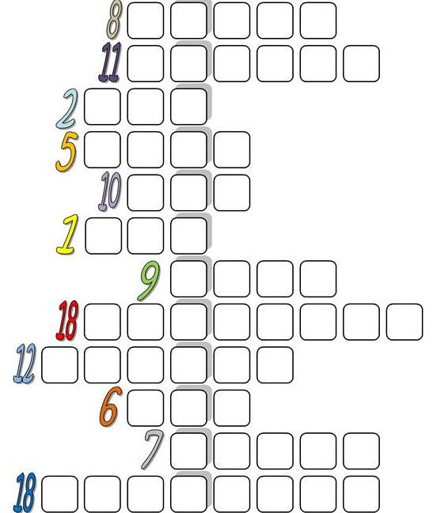

The message is: ________________________________________________________________
______________________________________________________________________________

