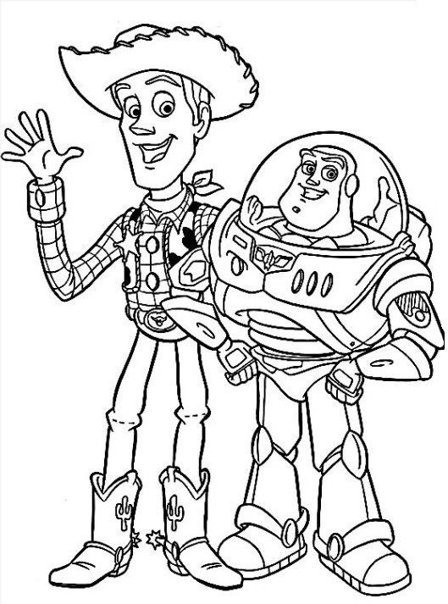
- Unscramble the school objects:
A) SAERER: ___________________.

B) TNEOKOBO: _________________________.

C) KBOO:___________________.

D) CNPILE:____________________.

E) CPILEN HREERSAPN:______________________________.

- According to question number 1, draw the school objects that you wrote.

- B) C)

D) E)

- Find 10 hidden school objects in the picture!
